Michelle DeCaire

Intermediate Programming: Project Two

Due 10/15/2015

File: GUI.java, Student.java

All Tests are numbered on the excel for convenience. Please note: The find, update, and delete features of the drop down will accept a student ID with no name. This is for ease of use. Since there is no duplication of ID numbers, this should not negatively impact the student records. Both the Student Name and Major field use the same method for input validation.

|  |  |  |  |  |
| --- | --- | --- | --- | --- |
|  | Test Cases | Expectations | Outcomes | Pass or Fail |
| 1 | Insert 3 students: 2222 Jacqueline K. Barton Political Science, 2667 Johannes Kepler Performing Arts, 2345 Lene Vestergaard Hau Pharmacology | success pop-up for all three | success pop-up | pass |
| 2 | delete: 2667 | this student has been successfully removed | success pop-up | pass |
| 3 | test Find:2345 (and GPA should be 4.0) | found, with major and GPA | success pop-up | pass |
| 4 | Test 4 find student 2345 no update | popup with major and 4.0 GPA | success pop-up | pass |
| 5 | Test update: update 2222 with 3 credits of b and 3 credits of c…. Should produce GPA 2.5 GPA | popup with major and 2.5 GPA | success pop-up | pass |
| 6 | Test grade Formula see five | popup with major and 2.5 GPA | success pop-up | pass |
| 7 | Test duplicate key insert test 2345 | popup asking for unique ID | unique ID pop-up | pass |
| 8 | Test key no found delete: testing deleted student 2667 | popup saying id not found | no such record pop-up | pass |
| 9 | Test ID not found Find; testing unique ID 3247 | popup id not found | no such record pop-up | pass |
| 10 | Test ID not found Update: testing # 12345 | popup id not found | no such record pop-up | pass |
| 11 | Test update dropdowns | dropdown | dropdowns | pass |
| 12 | Test To String Method: testing student 2222 | popup with GPA of 2.5 | pop with full student information | pass |
| 13 | testing non numeric input in ID field | error | error popup | pass |
| 14 | testing blank numeric input in ID field, name & major fields | error | error popup | pass |
| 15 | Testing numeric values in student name field (Note this field will handle periods, en dashes, and spaces) testing the number 5 | error | please enter alpha characters | pass |
| 16 | Testing character values in major field. Testing *** | error | error popup | pass |
| 17 | testing drop down box | this update was cancelled | cancel pop-up | pass |
| 18 | Testing rounding student 2345 should have 3.3 | Should have 3.33 GPA | To string with 3.33 GPA | pass |

Test 1. Inserting students

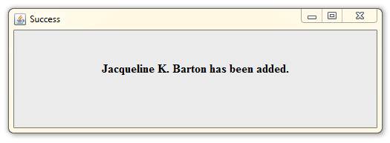

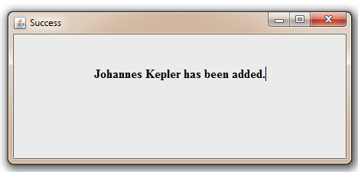

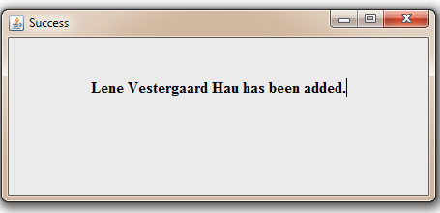

2. Tests the removal of student # 2667

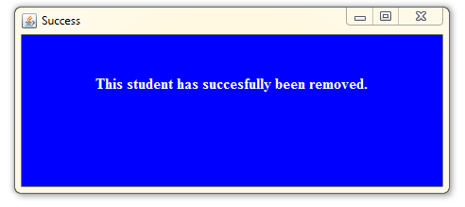

3 & 4. Tests 0 credit hour GPA of 4.0…Note because she has not completed credit hours her GPA is 4.0

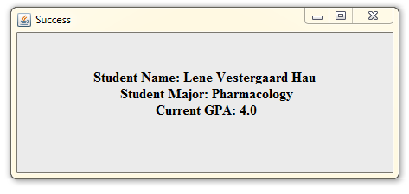

5 &6. Tests the GPA calculator. This student had 3 hours with a B grade and 3 hours with a C grade.

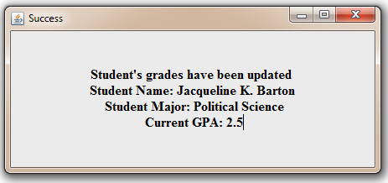

7. Tests whether the code will allow duplicate student ID #’s.

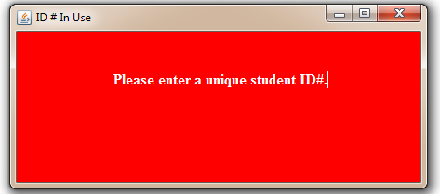

8. Tests non-existing record in delete option

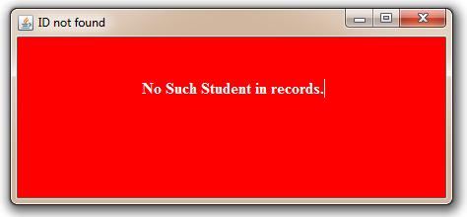

9. Tests non-existing record in Find option

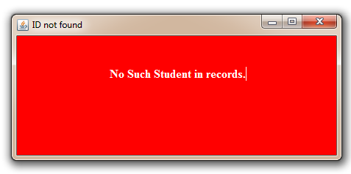

10. Tests non-existing record in update option

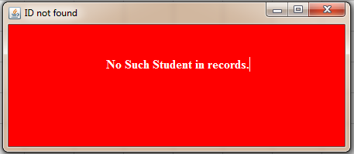

11.Testing drop downs for update field.

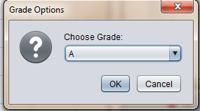

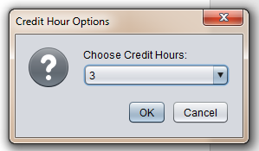

12. Testing to String method for student #2222

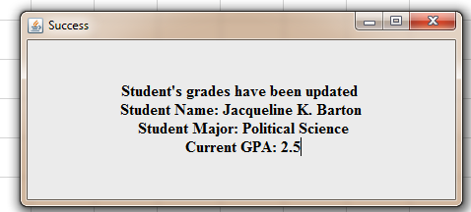

13. Testing non- numeric input in ID field

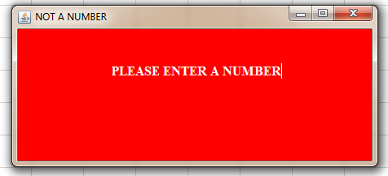

14. Testing blank input in ID field, and text fields

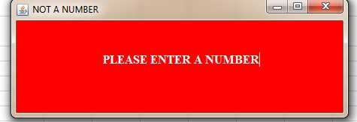

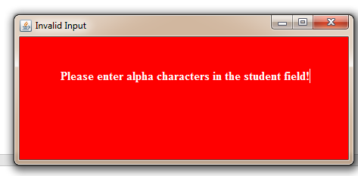

15. Testing numeric values in text field

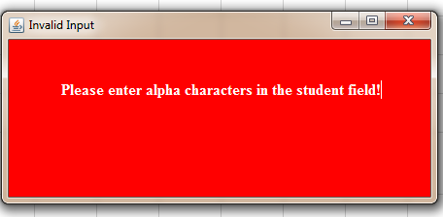

16. testing special characters in text field.

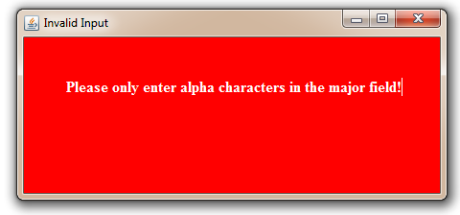

17. Testing the cancel button on the drop-down boxes.

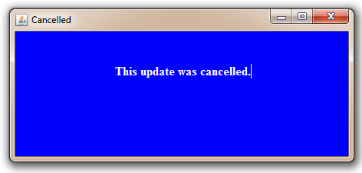

18. Testing the rounding of the GPA… student #2345 took 6 hours and got a B, then took 3 hours and got an A. This results in a GPA of 3.33

